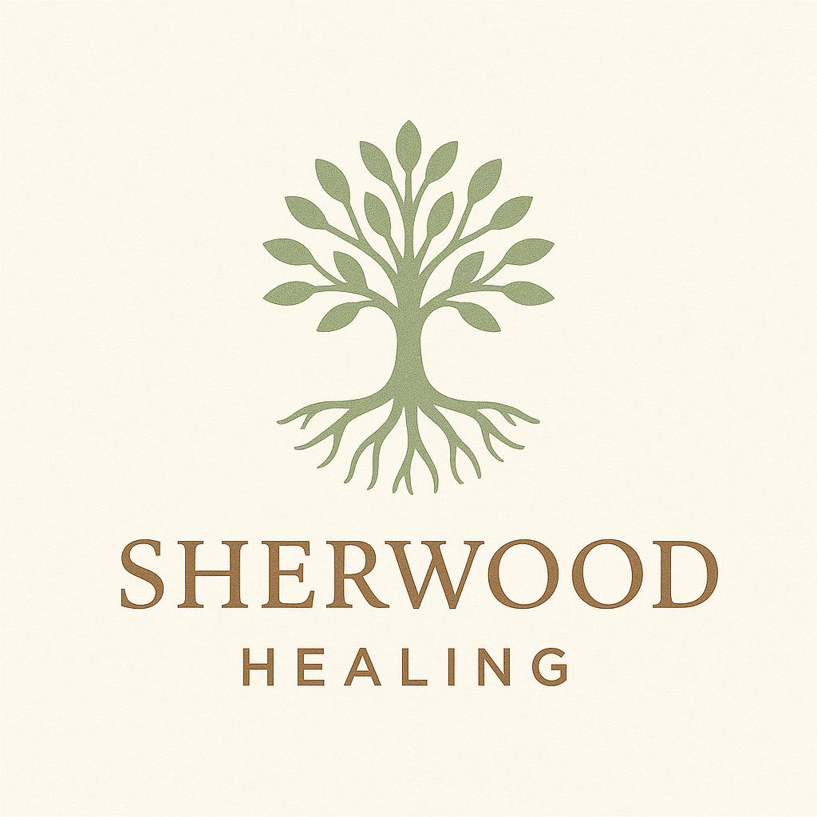

Sherwood Healing

Privacy Policy
Effective Date: 01/06/2025
​Welcome to Sherwood Healing. We are committed to protecting your privacy and ensuring that your personal information is handled in a safe and responsible manner. This Privacy Policy explains how we collect, use, and share your information when you visit our website and use our services.
​In order to undertake comprehensive treatments and support, We collect the following types of information:
- Personal Information: Name, email address, phone number, Address, Home information, Health history and emotional health concerns.
- Cookies and Tracking Technologies: We may use cookies to improve your browsing experience and analyze site traffic.
We use the information collected to:
- Provide and improve our services.
- Personalize your user experience.
- Communicate with you regarding updates, promotions, and customer support.
- Monitor website performance and enhance security.
We do not sell your personal information. However, we may share it with:
- Service Providers: GPs, other Health teams (this will be done with your consent)
- Legal Authorities: If required by law or to protect our rights and security.
- Business Transfers: In the event of a merger, acquisition, or sale of assets.
We implement security measures to protect your data from unauthorised access, disclosure, or alteration. However, no method of transmission over the Internet is completely secure.
You have the right to:
- Access, update, or delete your personal information.
- Disable cookies through your browser settings.
We are not responsible for their privacy practices, and we encourage you to review their privacy policies.
We may update this Privacy Policy periodically. Any changes will be posted on this page with an updated effective date.
Contact Us If you have any questions about this Privacy Policy at sherwoodhealing@gmail.com

