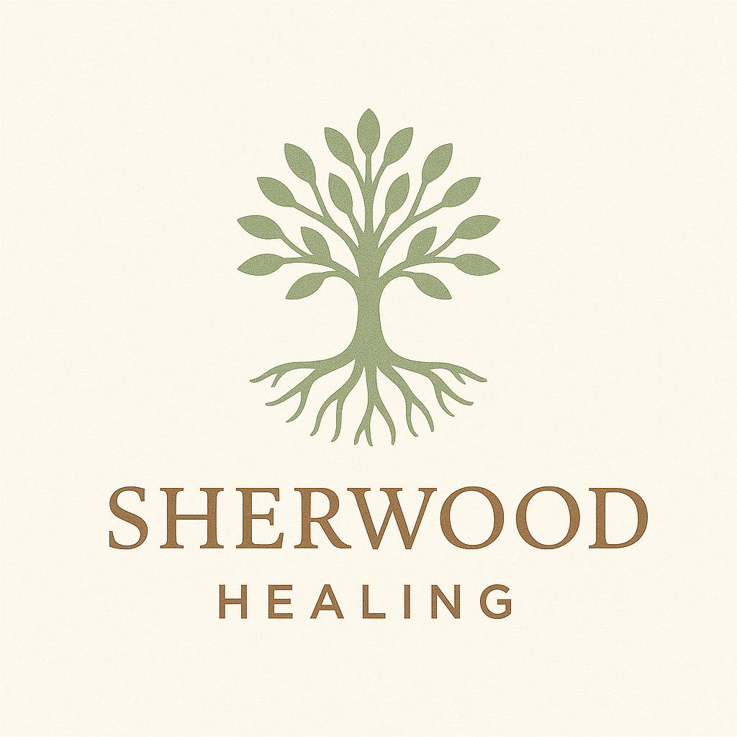

Sherwood Healing– GDPR/Data Protection Policy

1. Purpose of This Policy
This policy outlines how Sherwood Healing collects, uses, stores, and protects personal data in line with the General Data Protection Regulation (GDPR) and the Data Protection Act 2018.

2. Scope
This policy applies to:
- All personal data processed by Sherwood Healing
- All staff, contractors, and associates
- All clients, enquirers, and website users

3. Our Commitment
Sherwood Healing is committed to:
- Only collecting data we need
- Processing data fairly, lawfully, and transparently
- Protecting all personal data from misuse, loss, or unauthorised access
- Respecting individuals’ rights under GDPR

4. What Data We Collect
We may collect and process the following data:
- Client information: Name, address, date of birth, contact details, GP details (where appropriate), emergency contact, and medical or psychological history relevant to therapy.
- Session notes: Brief notes from therapy sessions for continuity of care.
- Administrative data: Emails, invoices, payment information (not card details unless securely processed by a third party).

5. Lawful Basis for Processing
We collect and use personal data under the following lawful bases:
- Contract: To provide therapy services as agreed with the client.
- Legal obligation: To comply with legal requirements (e.g., safeguarding, insurance).
- Legitimate interests: For the safe and effective running of the business.
- Consent: In specific cases (e.g., marketing, newsletters).

6. How We Store and Protect Data
- Digital data: Stored securely on password-protected devices or encrypted cloud systems (e.g., [insert system like Google Workspace, Dropbox Business, etc.]).
- Paper records (if any): Stored in locked filing cabinets accessible only by the therapists.
- Session notes: Stored separately from identifying client information where possible.
- Retention: Client records are kept for 7 years after the last session, in line with insurance and regulatory guidance. For clients under 18, records are kept until they turn 25.

7. Sharing Data
We do not share personal data with third parties unless:
- Required by law (e.g., safeguarding, court order)
- With your explicit written consent
- Necessary for therapeutic care (e.g., liaising with a GP or another professional, with permission)
We do not sell or trade personal data.

8. Your Rights Under GDPR
You have the right to:
- Access your data
- Correct inaccurate data
- Request data erasure (in some cases)
- Object to processing
- Withdraw consent at any time (where consent is the lawful basis)
- Lodge a complaint with the ICO (Information Commissioner’s Office)
To exercise these rights, please contact us at:
Email: Sherwoodhealing@gmail.com
Phone: 07495 903858

9. Data Breaches
If a data breach occurs, we will:
- Contain and assess the breach
- Notify the ICO within 72 hours (if required)
- Inform affected individuals where appropriate

10. Policy Review
This policy is reviewed annually or sooner if data protection regulations change.

Policy Date : June 2025

